# LITERATURE REVIEW

## Literature Review Part 1: Initial investigation for the project/problem context area

For this part the report the developer will be discussing and doing research about the key features that will be needed for the demographic renting app. We will also be carrying out research to better understand the ‘problem’ area this projects solution will try to address.

The ionic framework is getting more popular every day at industry level since you can develop any mobile application with the help of web technologies and then produce them to all native application stores. “Progressive web apps actually work the bridge between native mobile web applications and apps. PWA offers design concepts, technologies, and web APIs, collectively which work in tandem to provide users, app-like experiences on the mobile web.” (Danis, 2018)

Ionic also uses various plugins to gain access to mobile applications features such as the camera, GPS, etc and it does it through using the Cordova plugins.

Before the ionic framework was used, developers used native coding to develop apps on windows, iOS and Android. All this required a dedicated and independent development for these platforms, but with ionic framework the developers can use It to work on hybrid apps.

In a past survey ionic framework have gained grounds for creating hybrid apps over native apps by seeing a decline from 20% to 2.9% for developers using native.

“Before the introduction of Ionic framework developers used Native coding to develop iOS, Android or Windows apps. And all these platforms needed a dedicated and independent development. With the Ionic framework, developers got to work with the new Hybrid apps.

In a 2017 survey, it was found that the hybrid apps are gaining grounds over native apps. The report says that in just two years, the percentage drop is 2.9% from a good 20% of developers exclusively using Native.” (Danis, 2018)



***Figure 1 – Iconic framework*** (Danis, 2018)

**Map Editor**

There is a variety of map editing tools available for use, for example, google API lets users design routes within the map in any location and allows developers to add features such as polylines, polygons, popups, etc; this provides developers with massive number of tools to make their map as detailed as needed. (Kalmanowicz, 2017).

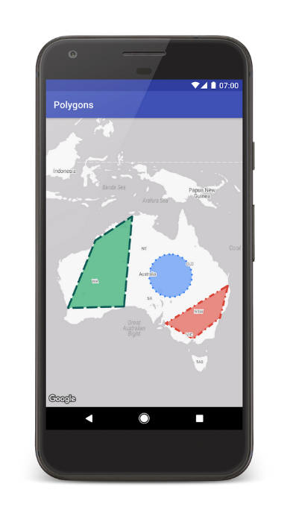

***Figure 2 – Google Map API editor*** (Kalmanowicz, 2017)***.***

Google now lets you store data objects with their markers now, they have extended their functionality to polygon and polylines as you can see in figure 2 above. This means that you can extended geometry objects to store any sort of data you require. You can now also store data on set of ground overlays and with each one you can store a database reference, using this the database it can contain real estate listings using URL clicks or listings of what anything you want. “You no longer need to manage your data associations to your mapping visualizations–nobody enjoys writing that code anyway. For example, if you supply a set of ground overlays showing home floor plans you could store a database reference with each one. The database can contain anything! It could hold real estate listings, and you could open one of those listing URLs on click.” (Kalmanowicz, 2017)

**Renting problems for young adults**

Alongside doing research for the project, I have made efforts to do research on the problems surrounding the project, how hard it is to find a desirable place to rent, issues regarding the high rental prices nowadays. On other hand people tend to rent more nowadays since the house prices are extremely high currently in many areas.

The landlords are even now refusing to rent to the young demographics in fear of rent not getting paid on time, fear of the property being destroyed or trashed. There is another case where too many young people are in receipt of either housing benefit or universal credit which hinders chances of finding a place go rent.

Landlords are refusing to rent their properties to young adults under the age of 35, scared that rents won’t get paid in time and contracts will be breached (Musaddique, 2017).

Research that has been done in university of Sheffield shows that around 30% of landlords have actively been wanting to change the letting strategy and some have changed their letting strategy already. Out of the survey done 32% have said that they plan to decrease renting out to young adults all under the age 35. While only 6% of landlords have said they are willing to rent their property to young adults under the age of 35 and hope to increase this within the next 3 years. This study makes some awful readings for the young demographics since, many are battling to survive with low or stagnant wages. Young people being on benefits like housing or universal credit really hinders any chance for them to find a place to rent and this is knock-on effect from wages being too low while living costs has increased.

The research also shows that 79% of the landlords said that the reason they have decreased renting to young adults under the age of 35 is because of the high risk from rent debt. A total of 68% mentioned higher risk of the tenancy condition getting breached.

The 4/5 of renters that said they would rent to the young adults under 35 only if as an additional security measure, the tenants are able to provide; use of guarantors and direct payments (Musaddique, 2017).

**House price inflation**

The house prices have been rising for a while now and they will not stop that soon, although in the past year house prices have stayed muted but in some areas the house prices have risen by 1 – 3 % and on the figure 3 below you can see what the house prices are predicted to rise by within the next 5 years.

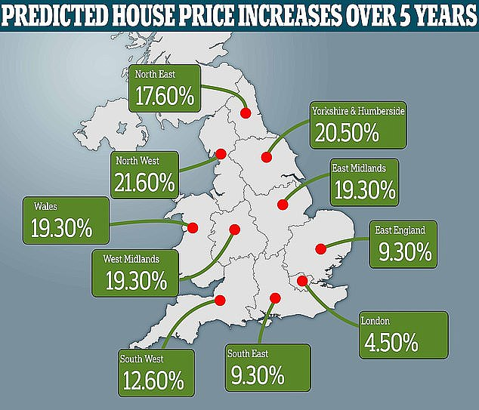

***Figure 3 – House price inflation*** (DailyMail, 2018)

As you can see there are few places with the increase in price; such as Yorkshire with 20.5% and some low areas in London, that will still rise by 4.5%.

The house prices not just in England but in the UK is increasing also, as you can see in figures 4 and 5, leaving the young adults to fend for themselves by finding landlords that will privately rent to them. Which is tough with low wages and no security if the landlord will kick you out without any substantial amount of time of notice.

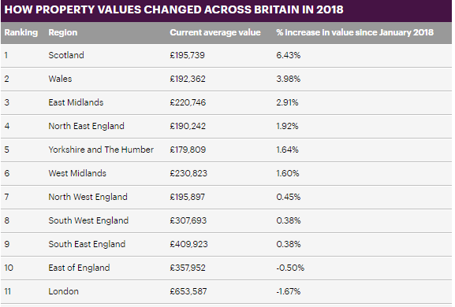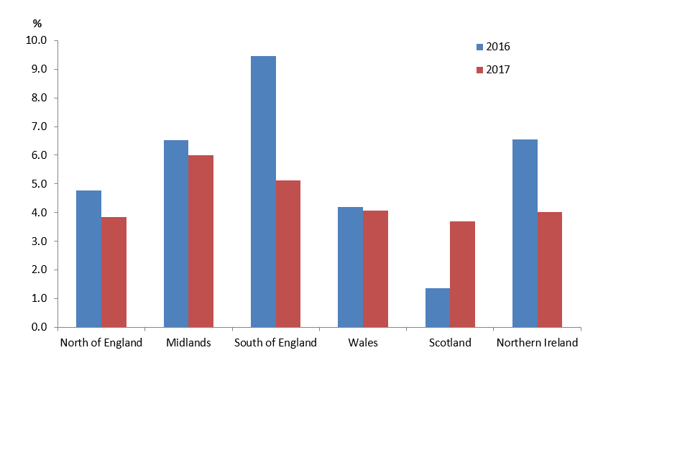

***Figure 4 – Property value*** (DailyMail, 2018)***. Figure 5 – Property value*** (HM Land Reg, n.d.)***.***

**Renters anxiety**

There are many that suffer from renter’s anxiety as it is known by. The millennials will never be able to own a home because of the rising price and property market crisis. Renters can be evicted at any time from the property they live in currently with just two months of notice. What affect does this have on one’s mental health you may ask?

A 30 year from Sheffield, named Brett chapman has lived in seven different houses in the past 10 years and has said that it is very stressful thinking about finding a place to rent especially if you have completed university. You can never make your home feel homely like you might want; since you cannot decorate it and you never know when you will have to leave the house to find a another one. Moving around every one or two years can be very intimidating.

Most of the young adults nowadays would need more than two hands to count the number of houses they have lived in since university and according to reports, a person has lived in 25 houses since graduating from university. Surely this has an adverse effect on a person’s wellbeing. This is what Chapman had to say from the stress caused by renting multiple times, “I struggled with depression when I was younger and my living situation was a part of that,” (Cosslett, 2019)

From a survey held the mental health charity mind had seen figures showing that almost 79% of young people had mental health problems due to the housing situation. The living situation either caused it or made their mental health worse. “figures showing that nearly 79% of people with mental health problems say a housing situation has caused a mental health problem or made their mental health worse.” (Cosslett, 2019).



## Literature Review Part 2 – Similar solution

There are currently some websites and applications out there that are loosely similar to the project but are not directly related to the problem area. Some of these websites and app are pretty standard that allow users to search for property to view but they are mostly used for property sales rather than focusing on renting and giving information about the area itself in much detail. Nowadays many websites have started to combine their websites to mobile applications; since using the new functionality plugins you can create hybrid apps that uses websites within the app itself.

In this part of the literature review the developer will compare some of these websites and apps to get a better understanding on the solutions that are used.

**Property Pal**

Property Pal is a good website which provides users with a variety of excellent functions such as searching for property to buy and now enabling users to search for property to rent. From the research of this solution, there are some similarities that can be drawn within this app and the proposed solution.



***Figure 6 - Property Pal App*** (PropertyPal, n.d.)

With property pal being well known before they started the app, they have substantial number of users and gaining above 10,500+ every hour. from reviewing the property pal website, it shows that the website is mainly used by users, estate agents, buyers and sellers for property use and not much for renting purposes since thy have just started to branch out to renters not so long ago. Property pal’s website design is professional, simple and elegant to the end user as you see in the Figure 6 above. Using the search criteria and the logging system to leave reviews is some of the features; that are similar to the proposed solution.

Overall the website is very well built and there are multiple features from this solution that can be taken into consideration for the proposed solution to enhance the end user needs. Once the project is complete and the mobile application is built the feedback section will be good to provide the developer with some insight upon how the proposed solution rates against other apps out there. In the table 2 below is the summary of property pal website

***Table 2 – Results of Property Pal***

|  |  |  |  |
| --- | --- | --- | --- |
| Design (1-5) | Functionality (1-5) | Navigation (1-5) | Notable Features |
| 3 | 3 | 4 | User profile, view the area and search for houses to buy or rent,  Can search for schools nearby. |

**Rent.com.au**

Rent.com.au is a very simple but elegant mobile application that is very similar to the project, it offers the user to search for homes to rent all over Australia. With over 100k download and 98,000 customers this app has become very popular from renters and I believe an app like this could benefit everyone across worldwide, since this app is only available to users in Australia.

The app uses the built-in function to help you find a place to rent fast, once you register and login to your account you can then enter in your resume which will be your personal renter resume for landlords to view. Your rental resume will be your own personal profile which will make you stand out as a renter and help you find a place that sooner. As you can see in figure 7 below the renter’s history is shown like a work resume.

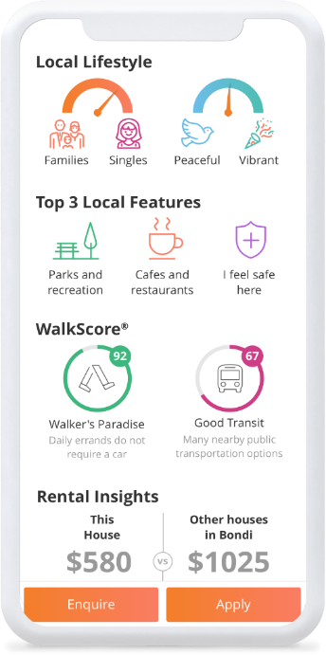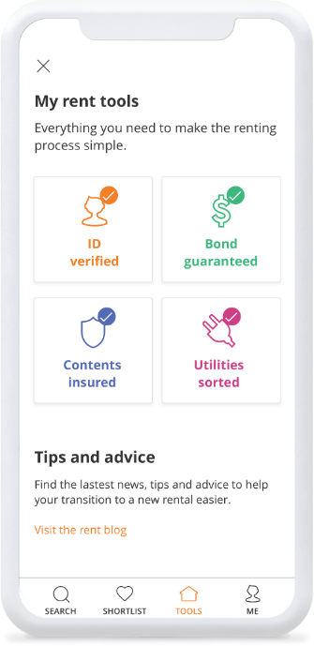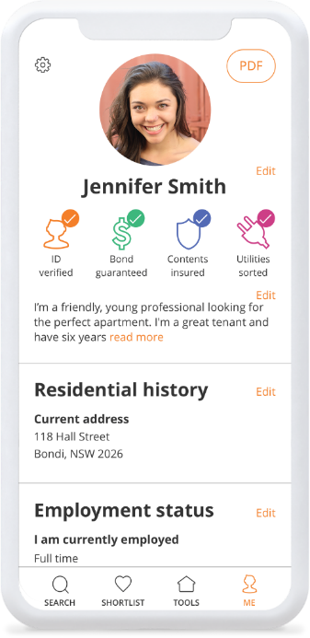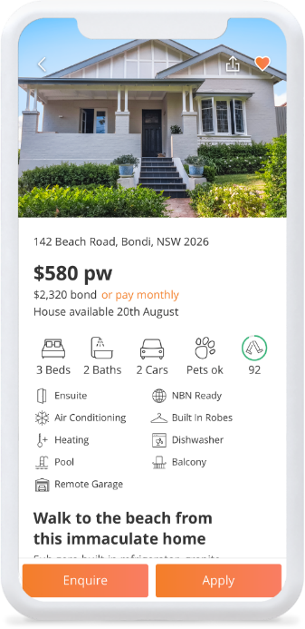

***Figure 7 – Rent.com.au App*** (Rent.com.au, 2019)

This solution is very good, it has a good design and relevant with many features. The app is supported for Android and iOS devices. The only limitations for this app is; that it is only available to users in Australia and it does not provide as much detail it should about certain areas. This limits user to know more about the area and its locality, since this is mainly focussing on getting users the house, they want to rent it is understandable. I would say this is the major difference between the solution and the proposed project.

Many elements from this solution can be incorporated for the proposed project since the design is extremely professional and uses current level features. The review section for this app is very useful also for the proposed project and will benefit the project in major way.

***Table 3 – Results for rent.com.au***

|  |  |  |  |
| --- | --- | --- | --- |
| Design (1-5) | Functionality (1-5) | Navigation (1-5) | Notable Features |
| 5 | 5 | 5 | User profile, view property fast, uses search function to search using users’ criteria, app for agents, renters and the landlord. |

**aspc Property Search App**

This app allows users to search for areas to rent or buy houses and it is localised only for Aberdeen. It is an app that is connected to Aberdeen estate agents to allow users direct communication. The applications design is very simple and generic, but the app could do better with an updated design and colour scheme. There is some great potential with this application, but it just does not fully use its capabilities. Apart from the simple design scheme the app has many negative reviews, mainly for not saving data from user’s search, every time the user opens the application, they need to re-enter their search criteria to find what they had searched for previously.

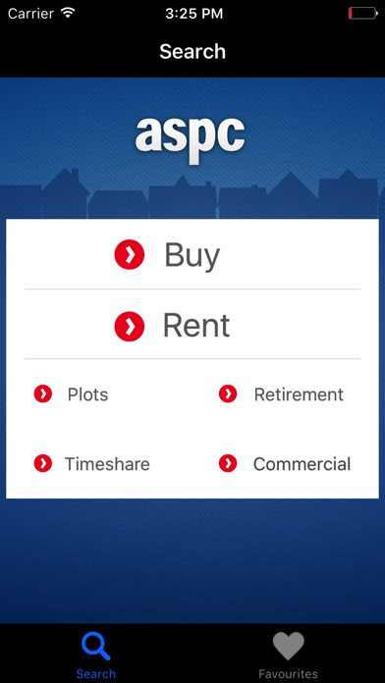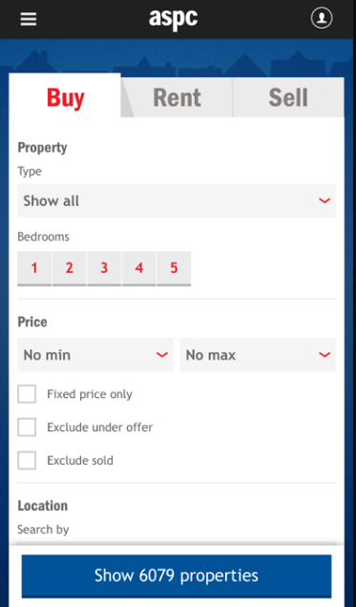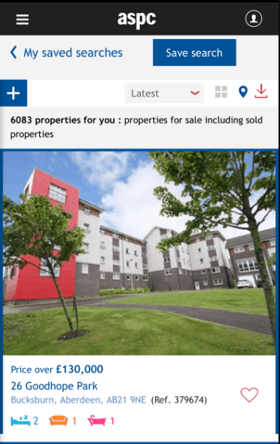

***Figure 8 – ASPC Property Search*** (aspcProperty, 2019)

The App does however offer some features that can be added to the proposed application, such as the search criteria, map API function, login functionality and it offers the user information about the area, population, sights of interests etc. However, the proposed app would provide more beneficial to the users and businesses than this app. The app has a section that provides users information about specific area’s locality which would be useful for the proposed solution and the feature can be improved further. This can be done simply by fixing the design layout and how the information is displayed to the user to make it more user friendly. Below in table 4 is the summary of aspc app.

***Table 4 – Results of ASPC Property Search***

|  |  |  |  |
| --- | --- | --- | --- |
| Design (1-5) | Functionality (1-5) | Navigation (1-5) | Notable Features |
| 2 | 2 | 2 | Search function, login/register function, detailed information about the area and its locality. |

**Zoopla app**

Zoopla is a very popular website for viewing properties to purchase, the website allows you to search for houses depending on the price, rooms, area etc and now they have an app which allows users to search for houses to buy or rent. When Zoopla first released their mobile app to iPhone/Android, in its first two weeks it had gained over 50,000 downloads and became the UK’s top property market app. The features within this mobile application is that, they allow users to search for many properties to buy, let or rent while on the go, it provides details with house prices dating back early as 1995, it has a new augmented function to view areas and a local market data analysis to allow users view the prices of properties in different areas. These features provide users with multiple benefits and some of these features are similar to the features that will be implemented within the proposed solution.

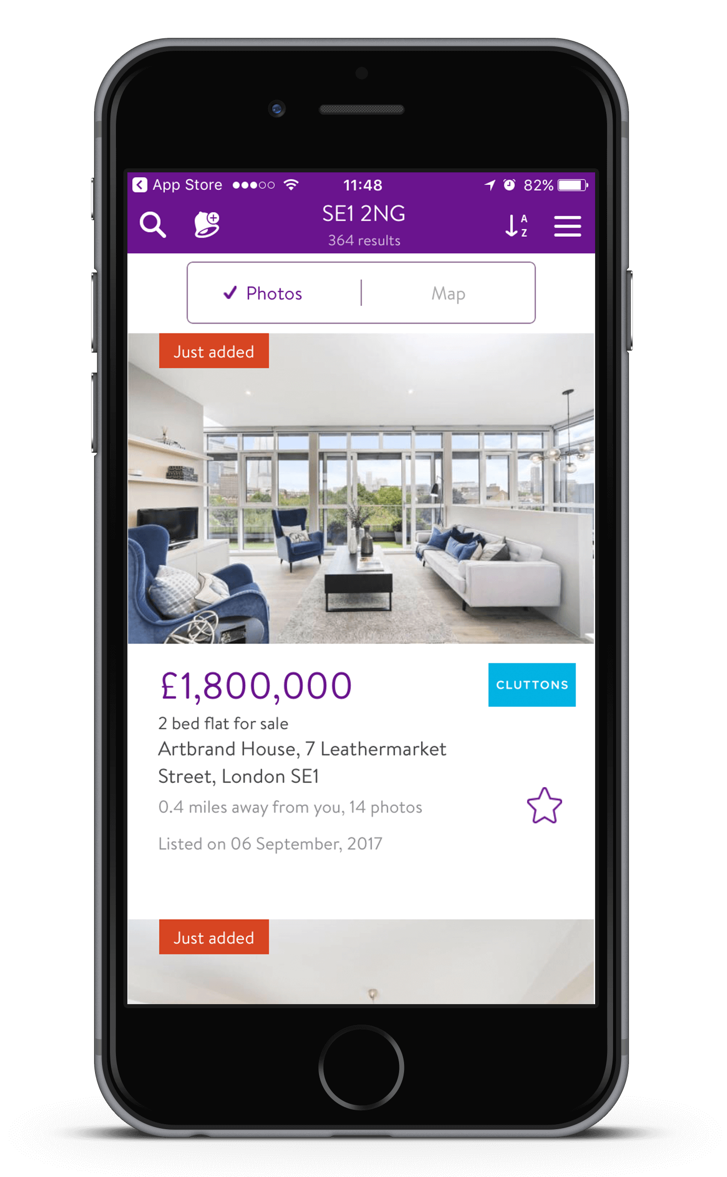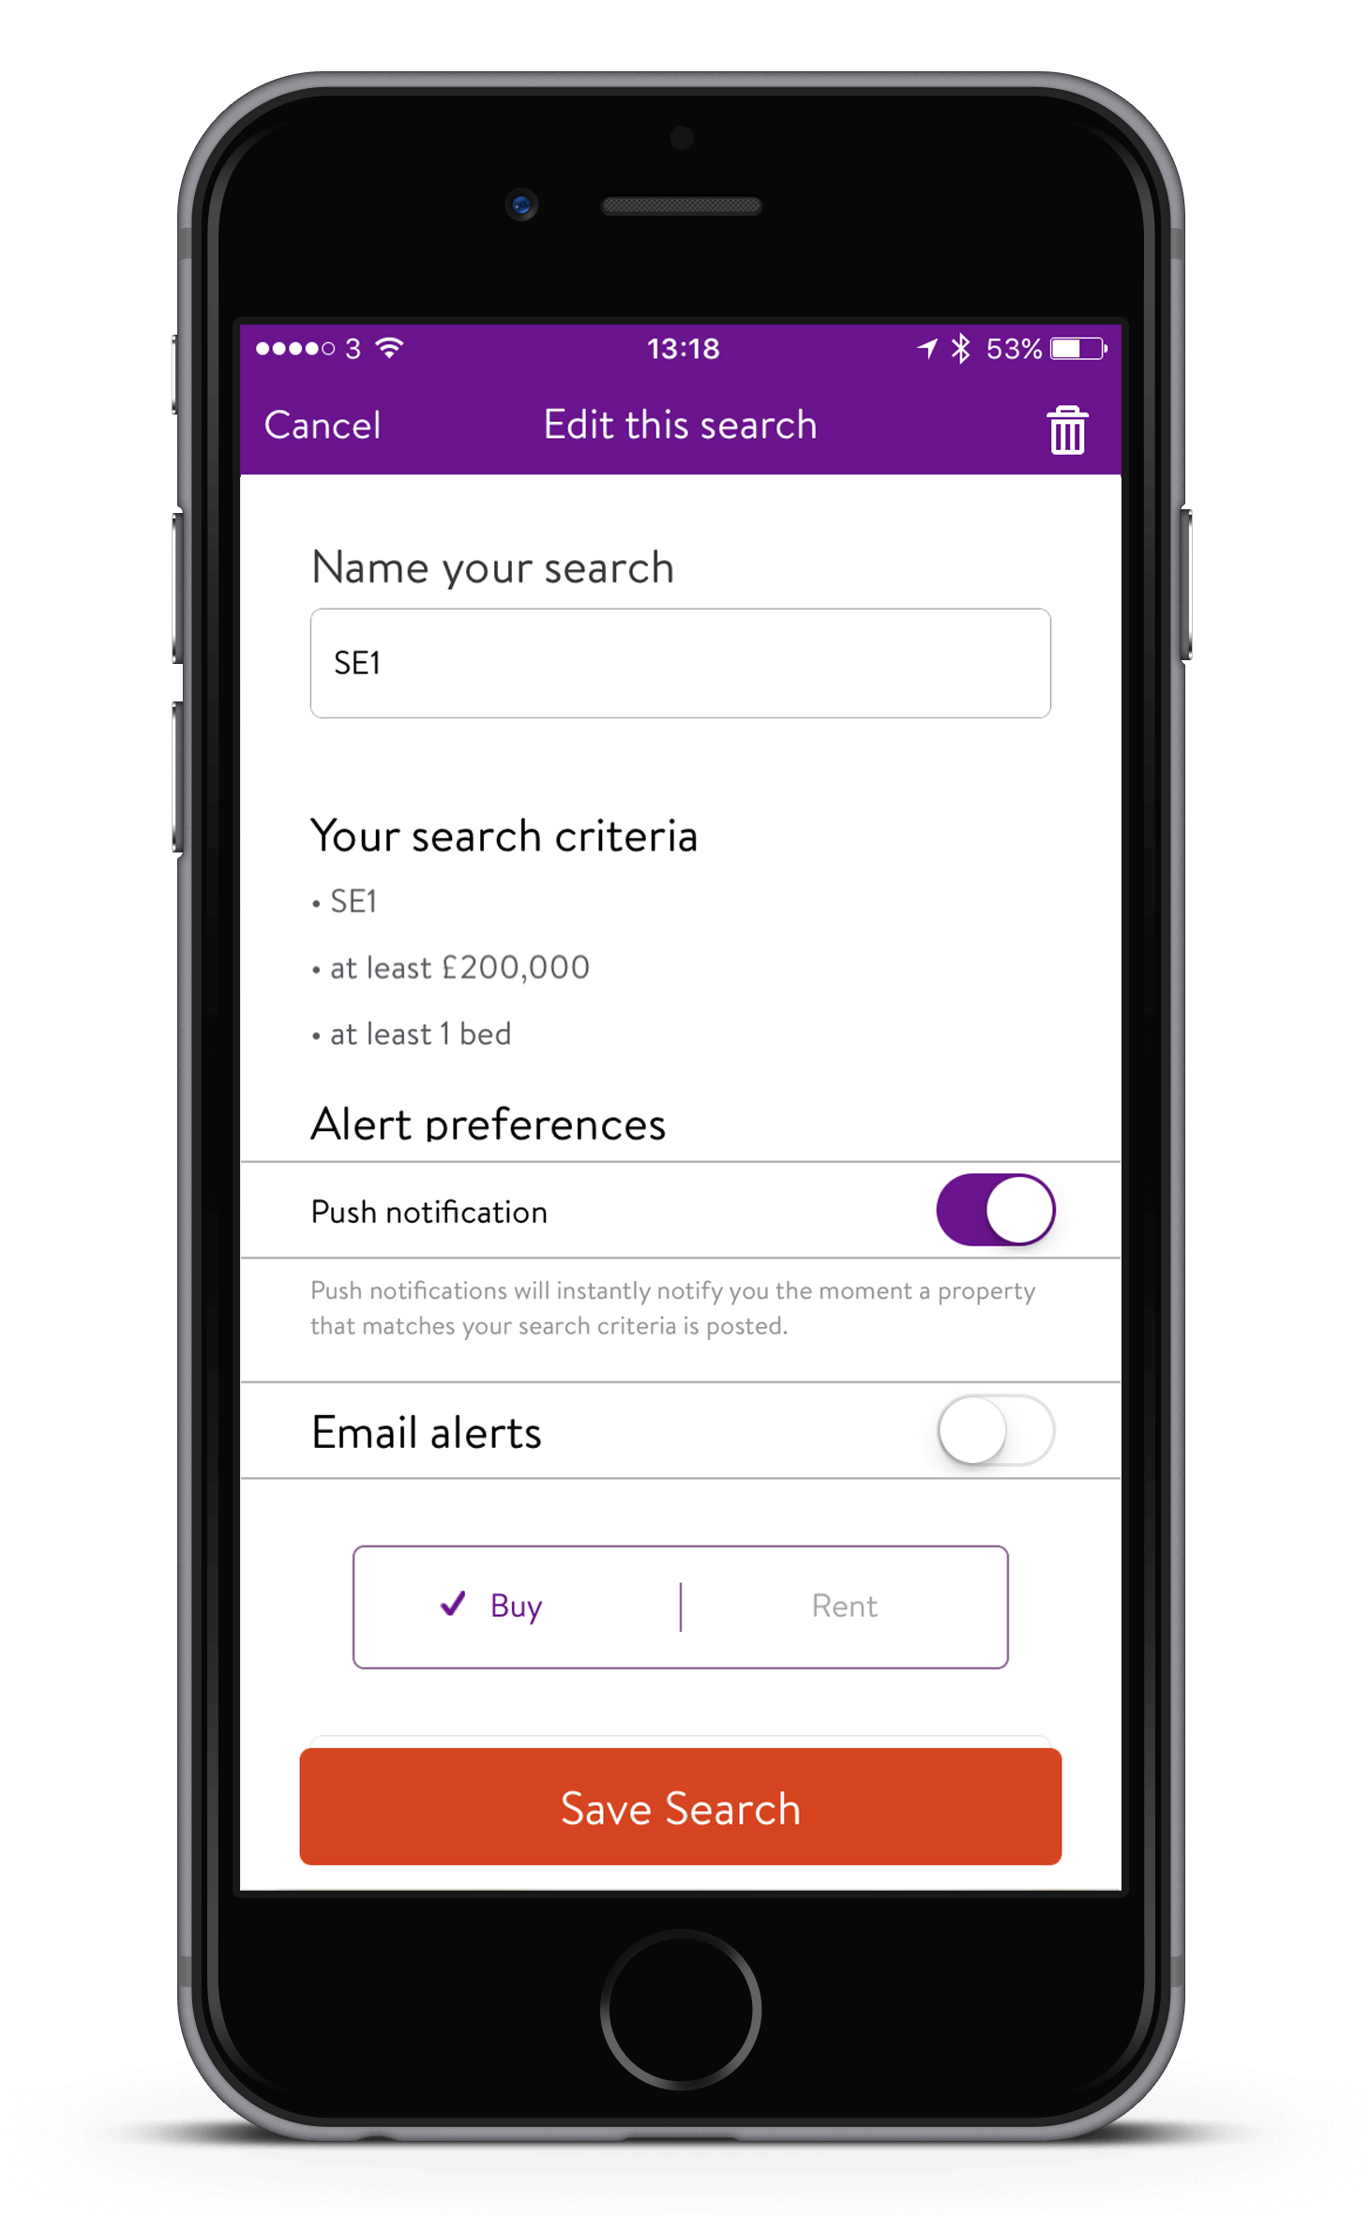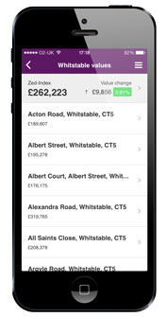

***Figure 9 – Zoopla app*** (Zoopla Limited, 2019)

The design scheme and layout could be better and compared to few other mobile applications that have been reviewed, in spite of that fact the app is very well built as you can see in figure 9 above. The main focus with these properties mobile application is that they focus on renting as well as house sales which divides their resources. The app provides details regarding the houses more rather than the area itself and information about the locality and public services (Zoopla Limited, 2019).

After researching some reviews for the mobile application, most of the consumer feedback was with the design of the mobile application and few features, in the table below are the summary of Zoopla app. Summary will take into account the design of the app, functionality, navigation and any notable features.

***Table 5 – Results of Zoopla Mobile Application***

|  |  |  |  |
| --- | --- | --- | --- |
| Design (1-5) | Functionality (1-5) | Navigation (1-5) | Notable Features |
| 2 | 3 | 3 | Display house prices for different areas using local market data analysis, uses search function to search using users’ criteria. |

**Results summary**

Below in table 6 it shows the summary of all the 4 apps that have been researched and ranked how well each is by overall score.

***Table 6 – summary of results***

|  |  |  |  |
| --- | --- | --- | --- |
| Solution Name | Relevance to Project | Size of business | Overall score |
| Property Pal | 4 | 5 | 5 |
| Rent.com.au | 5 | 5 | 5 |
| aspc Property Search | 3 | 2 | 3 |
| Zoopla | 4 | 4 | 4 |